Use-Case Realization Report (Design)
Add Outline

Issue <1.0>
Revision History
Date | Issue | Description | Author
29/11/09 | 1.0 | Initial Version | Rajendran Kumaraguru

Table of Contents
1. Brief Description 4
2. Flow of Events 4
2.1 Standard Flow 4
2.2 Exception Flow 4
3. Interaction Diagrams 5
3.1 Sequence Diagram for Add Outline 5
4. Participating Objects 5
5. Class Diagrams 6
5.1 Class Diagram for Add Outline 6
6. Derived Requirements 6

Use-Case Realization Report (Design)
Add Outline

Brief Description
Upon successful login of the portal admin and once the company is created thru ACS module, subsequently after the site creation then the outline will be created for customer who purchased the service

Flow of Events

Standard Flow
- Portal Admin login into the system.
- Portal admin clicks btnAddClick() to add the outline for the newly created site.
- Check whether the outline is already created.
- Validate fields will be validating the input values while creating the outline
- Then outline will be created
- Upon successful creation of the outline the message will be shown to portal admin.

Exception Flow
  - If the outline is already created then there should be exception message thrown to portal admin.
  - Validate fields should be thrown the validation error message to portal admin.

Interaction Diagrams

Sequence Diagram for Add Outline
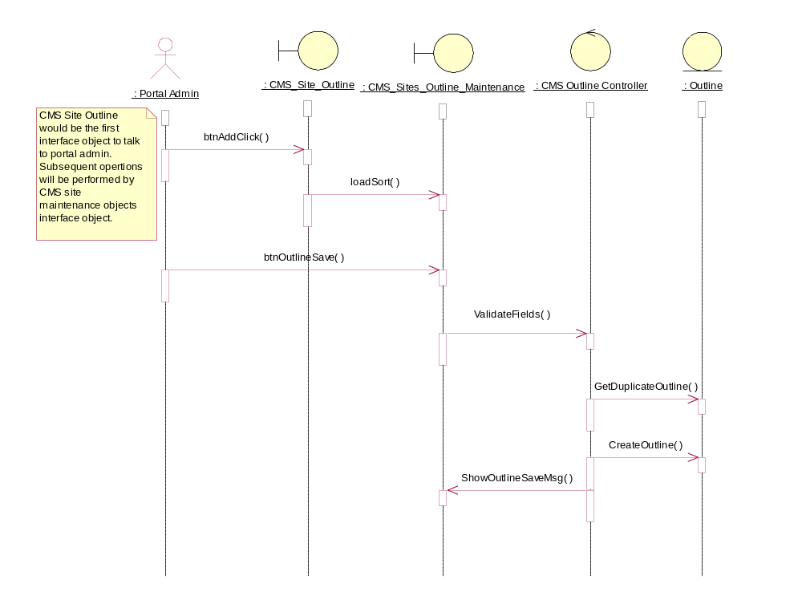

Participating Objects
: CMS Outline Controller

: CMS_Site_Outline

: CMS_Sites_Outline_Maintenance

: Outline

: Portal Admin

Class Diagrams

Class Diagram for Add Outline
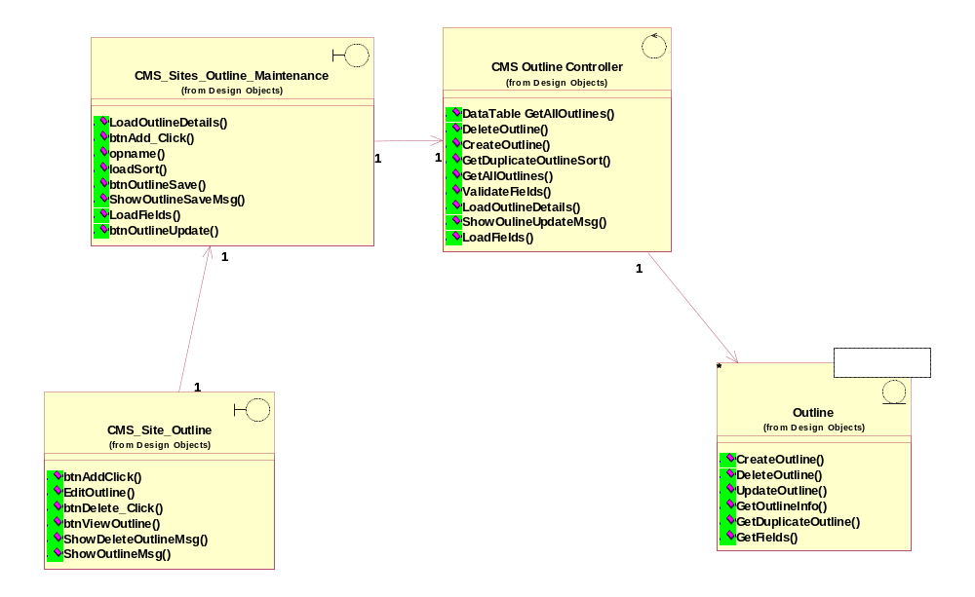

Derived Requirements
[enter the derived requirements here]

